DB-C4-S3-THEORY (VIEW EXERCISES)

# What you will know:

## SQL CREATE VIEW Statement

This exercise is based on given ONLINE database:

<https://www.w3schools.com/sql/trysql.asp?filename=trysql_select_where>

* Test your queries on the online editor
* Copy / paste your answer for each question on this document

**Q1:** Write a query to create a view for all customers who are coming from France.

Your answer:

CREATE VIEW [France Customers] AS

SELECT CustomerName, ContactName

FROM Customers

WHERE Country = 'France';

**Q2:** Write a query to create a view of order quantity more than 50.

Your answer:

CREATE VIEW [Greater Ordersing] AS

SELECT OrderDetailID, Quantity

FROM OrderDetails

WHERE Quantity >=50;

Q3: Write a query to create a view of products with a price between $10 and $30.

Your answer:

CREATE VIEW [Price $10 - $30 ] AS

SELECT productname

FROM products

WHERE price between 10 and 30;

Q4: Write a query to create a view of suppliers coming from Japan and only from Tokyo city .

Your answer:

CREATE VIEW [New Suppliers in Tokyo] AS

SELECT suppliername

FROM suppliers

WHERE country = 'Japan' and city = 'Tokyo';

**Q5:** Write a query to create a view to display product name in each category without any duplicate.

Expected :

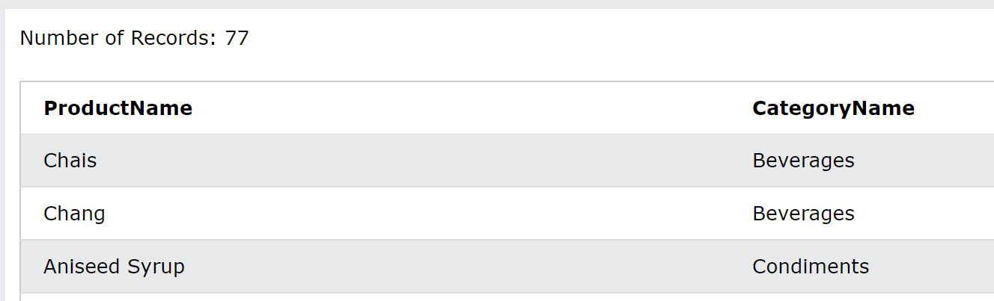 Your answer:

CREATE VIEW [Products Each Categories] AS

SELECT distinct products.productname, categories.categoryname

FROM products

INNER JOIN categories on products.categoryid = categories.categoryid;

**Q6:** Write a query to create a view to display all customers and employees as seller.

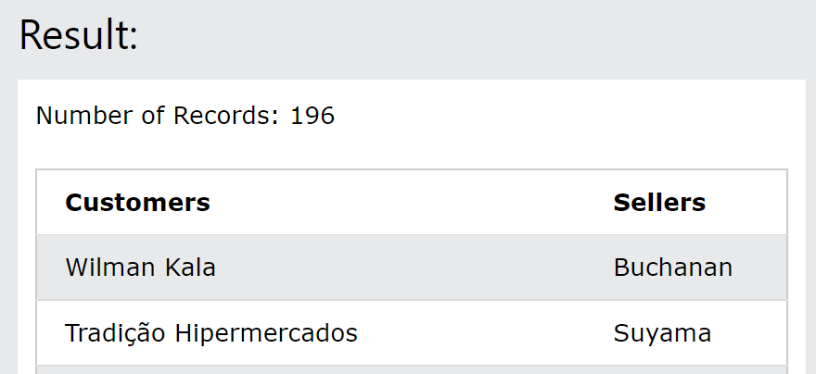

Your answer:

CREATE VIEW [Customer&Sell] AS

SELECT customers.customername as "Customers", employees.lastname as "Sellers "

FROM orders

join customers on orders.customerid = customers.customerid

join employees on orders.employeeid = employees.employeeid;

Q7: Write a query to create a view for those salesmen belongs to the city New York. 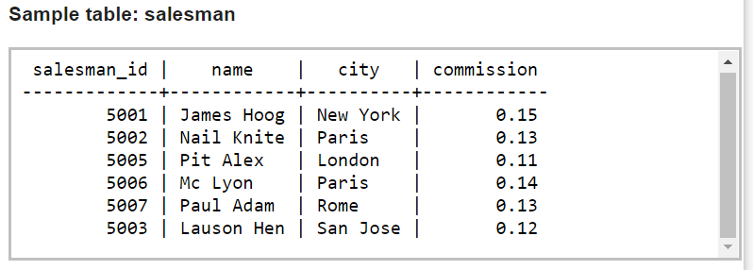

Your answer:

CREATE VIEW newyorkstaff

AS SELECT * FROM salesman WHERE city = 'New York';

**Q8:** Write a query to find the salesmen of the city New York who achieved the commission more than 13% with the view you just created in Q7.

SELECT * FROM newyorkstaff where commission > .13;